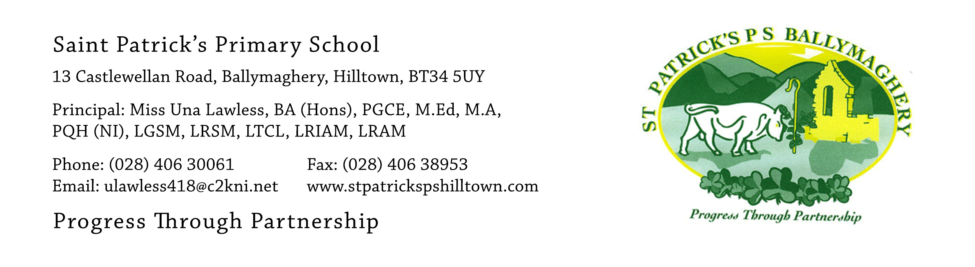

26th June 2020

Dear Parents,

As we near the end of the school year, we want to take this opportunity to thank you all, most sincerely, for the wonderful work you have done at home with your children during the period of school closure. It has been great to keep in touch with you via the website, Seesaw and phone calls and we have loved seeing the excellent work which the children have completed, along with their voice messages, videos and photos.

All children have now collected their books and school reports and the staff wish to thank you for all the cards and good wishes. The teachers loved seeing the children again to say ‘goodbye’ and it was obvious that the children were happy to see their teacher. Thank you also for returning most of the school books. If you find any more at home, please keep them safely until the children return to school in August.

The Parent Survey showed that you were very happy with the school provision throughout the fourteen weeks of closure and we are glad that we were able to provide a meaningful educational experience for your children, albeit remotely. Our teachers worked diligently throughout the school closure and we thank them for their effort and dedication.

Now we look ahead to the next school year. On 19th June the Department of Education published the document ‘Northern Ireland Re-Opening School Guidance: New School Day’. As we work our way through this guidance, we are putting together provisional plans for the children to return to school after their summer holidays. All staff and parents want the children to return to fulltime education, but we also want everyone to be as safe as possible. We will work hard to ensure that we meet both aims.

- In accordance with DE guidance we hope to reopen the school on Monday 24th August. This will be an induction week, which will focus on the pastoral needs of the children, their health and wellbeing and the enhancement of a ‘reconnect’ between pupils and school, helping our pupils settle back into the new school day and the changes to the school routines. Pupils in P.2 – P.7 will return in small groups and have two morning sessions during this week, from 9am – 12noon, with their teacher. We will notify you on Monday 17th August as to which mornings your child will attend during the week of 24th - 28th August. Siblings will attend on the same two mornings. There will be no dinner or lunch during this week. Our new P.1 pupils have their own arrangements and a letter was posted to each family of our new P.1 pupils yesterday, 25th June.
- During these ‘settling back’ sessions, staff will also spend time reinforcing the good practice which you have been undertaking at home to help minimize the spread of Covid-19. This will include regular, thorough hand-washing and the use of wipes and hand sanitisers. We ask that each parent provides their child with a packet of tissues, a packet of anti-bacterial wipes and a small bottle of hand sanitiser. These items should be labelled with the child’s name and will belong to the child but will remain in school for daily use.
- On Tuesday 1st September we aim to have all children back to school each day (subject to guidance from DE). Again, P.1 pupils have their own arrangements for this week.
- Additional guidance will be given in August concerning drop-off and pick-up times and we will aim to stagger these in order to reduce the number of people who are in the carpark and playground at any one time. The ‘drop-off’ timeslot is likely to be between 8.45 – 9.15am, with no facility to drop the children off any earlier, due to the current restrictions.
- While the school is operating under Covid-19 prevention guidance, parents are asked to remain outside the school buildings at all times to reduce footfall and the potential spread of the virus. If necessary, parents may make an appointment to see the principal after 3.15pm, when all children are safely off the premises. Contact with teachers will be by phone appointment.
- School dinners will be available from 1st September and if you think your child may be eligible for Free School Meals, Uniform or Transport assistance please apply for these soon by filling in the on-line form on the Education Authority website at: www.eani.org.uk.
The E.A. website currently states that the form will be available from late June.
- Pupils are asked to wear a fresh uniform every day, if at all possible, to reduce the risk of infection. To make this a little easier for parents we have agreed that for the period in which the school is operating under Covid-19 prevention guidance, all pupils may wear their tracksuit each day. The children will therefore need two tracksuits and two yellow t-shirts. We have no doubt that this will be extremely popular with the majority of our pupils, but we would hate the school to lose the beautiful uniform we currently have for pupils in P.3 - P.7, in which they look exceptionally smart, so full school uniform will be re-introduced when everything returns to normal. If any child wishes to wear their full uniform to school any day we will be delighted to see it!
- When children return to school, they will each be provided with a large plastic zip folder. The school will provide each child with their own pencil, rubber, ruler, crayons, colouring pencils, pritt stick etc. These items will remain in the child’s zip folder and no one else will touch them or use them. Children will bring their own packet of tissues, wipes and hand sanitizer from home and they will remain in this zip pocket. Nothing will be brought in or out of school and no school bags or lunchboxes will be used. Packed lunches should be in disposable packaging, please. Pupils may bring a bottle of water daily. There will be no use of the water fountains to refill bottles.

As guidance may change over the summer, these plans are provisional. Please access and follow the school’s communications via our website and app for up-dates.

We will be delighted to welcome the children back at the end of August as we have missed them all very much. Sincere thanks for all your help and co-operation throughout 2019-2020.

We wish you and your family a peaceful and relaxing summer break.

Yours faithfully,

Una Lawless
Orla Reavey
Plunkett Mc Conville
Catherine Murphy
(Senior Leadership Team)

